**GENERAL INFORMATION**

Standards - Acme Screw Threads B1.5 - 1997(R2014) [1]

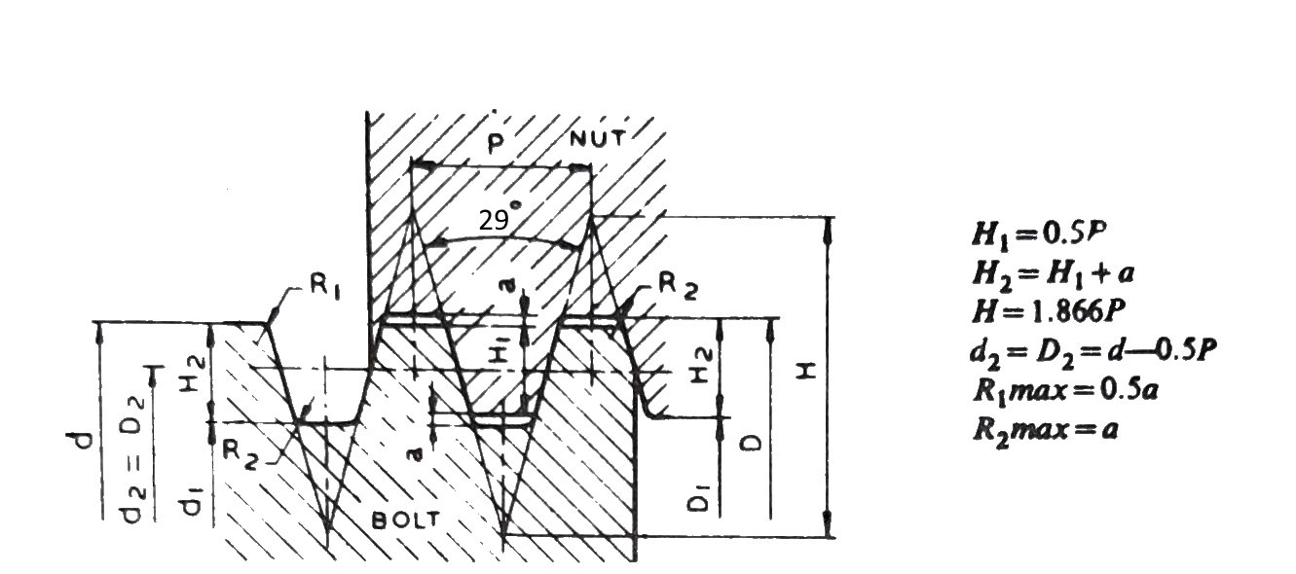Fig 1 – ACME Screw Thread profile (modified from Trapezoidal threads i.e. 300) [2]

|  |  |  |  |  |  |  |  |
| --- | --- | --- | --- | --- | --- | --- | --- |
| Nominal dia.  **d** (mm)  (Major dia. of bolt) | Pitch  **P** (mm) | Major dia. of nut  **D** (mm) | Minor dia. (mm) | | Pitch dia.  **d2 = D2**  (mm) | Crest allowance  **a**  (mm) | Core area  **cm2** |
| Bolt  **d1** | Nut  **D1** |
| 8 | 1.5 | 8.3 | 6.2 | 6.5 | 7.25 | 0.15 | 0.3 |

Table 1: Standard data for 8mm screw thread profile [2]

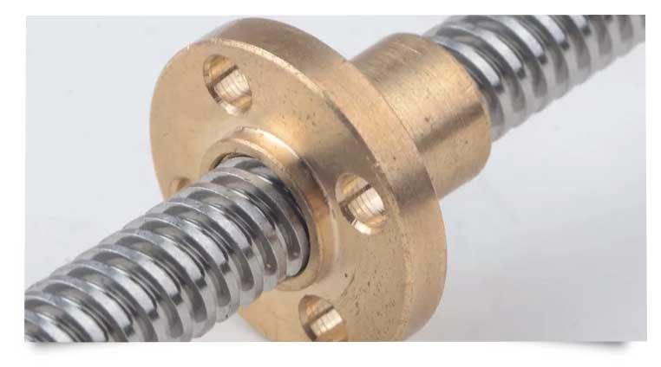

Fig 2 – ACME Lead Screw and nut [3]

The gap maintained between screw and nut is Crest Allowance (**a)** which **is 0.15mm**

**VENDOR VARIATIONS**

Main Parameters: Nominal dia. d: 8 mm Start: 4

|  |  |  |  |  |  |  |  |
| --- | --- | --- | --- | --- | --- | --- | --- |
| Vendor Coy. Name | Nominal dia. (Max.)  **d** (mm) | Pitch  **P** (mm) | Major dia. of nut  **d** (mm)  min. | Minor dia. (mm) | | Pitch dia.  **d2 = D2**  (mm) | Crest allowance  **a**  (mm) |
| Min.  **d1** | Max.  **d1** |
| Igus [4] | 8 | 1.5 | 7.8 | 5.4 | 6.2 | NG | NG |
| 3dprintronics [5] | 8 | 2 | NG | NG | NG | NG | NG |
| Malker | 8 | 2 | NG | NG | NG | NG | NG |
| Involine (Peenya) | 8 | 2 | NG | NG | NG | NG | NG |

NG – Not Given

Table 2: Given data for the mentioned vendors’ lead screw

Observations:

|  |  |  |  |  |  |  |  |
| --- | --- | --- | --- | --- | --- | --- | --- |
| Vendor Coy. Name | Nominal dia. (Max.)  **d** (mm) | Pitch  **P** (mm) | Major dia. of nut  **d** (mm)  min. | Minor dia. (mm) | | Pitch dia.  **d2 = D2**  (mm) | Crest allowance  **a**  (mm) |
| Min.  **d1** | Max.  **d1** |
| Igus [4] | 8 | 1.5 | 7.8 | 5.4 | 6.2 | NG | NG |
| 3dprintronics | 8 | 2 | NG | NG | NG | NG | NG |
| Malker | 8 | 2 | NG | NG | NG | NG | NG |
| Involine (Peenya) | 8 | 2 | NG | NG | NG | NG | NG |

References:

1. <https://www.asme.org/codes-standards/find-codes-standards/b1-5-acme-screw-threads>

2. Central Machine Tool Institute (2017), **Machine Tool Design Handbook**, 1st ed. Bangalore: McGraw Hill Education

3. <https://www.micrometals.co.in/acme-threaded-rod-nut-bolt-suppliers/>

4. drylin® trapezoidal lead screw, right-hand thread, C15 1.0401 steel

Link: <https://www.igus.in/product/?artnr=PTGSG-08X1.5-01-R>,

Datasheet Link: <https://www.igus.in/contentData/Products/Downloads/drylin_trapezoidal_lead_screw_right-hand_thread_steel_C15_10401.pdf>

5. 8mm Metric Acme Lead Screw (1.05 mtr)

Link: <https://www.3dprintronics.com/8mm-Metric-Acme-Lead-Screw-1-05-mtr-p94342017>